





 AUSTRALIA’S 

DEFENCE

 SPACE STRATEGY



















|  |
| --- |
|  |





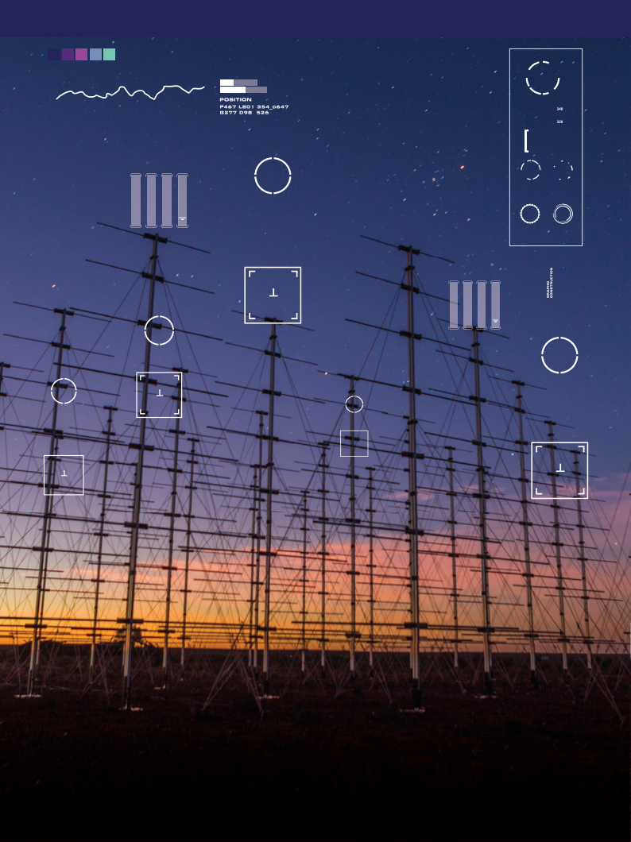FOREWORD















© Commonwealth of Australia 2022

First Edition 2022

Sponsor

Chief of Air Force

Developer and Publisher

Defence Space Command

VERSION STATUS

First Edition, 2022

Proposals for amendment are to be forwarded to: Director General Space Strategic Plans F3.2.105| Fairbairn ACT 2610

Department of Defence

CANBERRA ACT 2600

This work is copyright. Apart from any use as

permitted under the Copyright Act 1968, no

part may be reproduced by any process

without prior written permission from the

Australian Government Department of

Defence. All Defence information, whether

classified or not, is protected from

unauthorised disclosure under the Crimes Act

1914, Defence information may only be

released in accordance with the Defence

Security Principles Framework as appropriate.

**2**

Foreword from the

Minister for Defence

The Hon Peter Dutton MP

Space has been vital to our national security for decades. The Department of Defence has acknowledged the importance of space, by recognising the space domain alongside the existing warfighting domains of air, maritime, land and cyber.

The release of the *Defence* *Space* *Strategy* represents a key milestone for Defence. The *Defence* *Space* *Strategy* describes the strategic context in the space environment, articulates our vision and mission for the space domain and sets out the underpinning objectives that will realise our 2040 vision as an integrated space power.

For most Australians, the benefits of what the space domain provides are largely invisible. The ease with which technology enables our everyday lives hides our reliance on space. Increasingly, the space environment is becoming a more congested and contested place in which to operate, one in which Defence is tasked with protecting our national interests. Losing access to space would impact not just our national security, it would fundamentally impact our way of life. The military consequences of losing access to space are significant, with much of our forces reliant on space-based communications, intelligence and navigation.

In order to manage these risks, our shared vision is for “Assured Australian civil and military access in space, integrated across Government, and in concert with the United States, other allies and partners and industry”. Our vision recognises Defence is one component of a whole of Australian Government approach to space capability.

As a global domain we must also work closely with our allies and international partners to mutually assure our access to space capabilities. It is also imperative that Defence partners with Australian industry in order to make the most of our opportunities and deliver sovereign capability options. The Australian Government is aiming to triple the size of the Australian space sector by 2030. Defence is a key contributor by advancing Australian sovereign space capability to support the development of a sustainable national space enterprise.

We are experiencing an unprecedented level of activity within the space domain and with that activity comes both threats and opportunity. Defence has a strong interest in building on the progress of space capabilities. However there is significant work to be done. Many of the lines of effort identified in this Strategy have a time horizon within the next five years. The immediate priority for Defence is to better integrate the many diverse elements of space capability within the Defence Force. This evolution in our operational capability will ensure we can respond efficiently and effectively to meet this challenge.

The *Defence* *Space* *Strategy*will help ensure Australia can overcome new and emerging threats and seize the many opportunities that this new era in space power presents.



Minister for Defence

The Hon Peter Dutton MP

**3**



CONTENTS























**4**

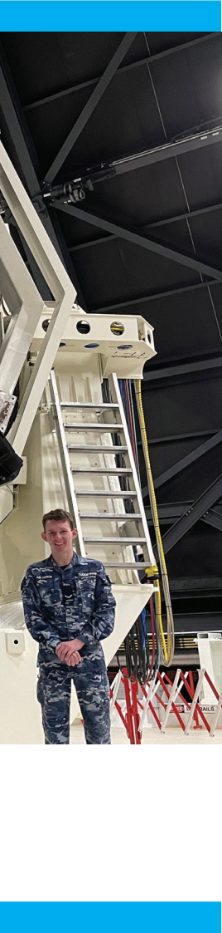

CONTENTS

STRATEGIC CONTEXT 7

AUSTRALIA IS CRITICALLY RELIANT ON SPACE ACCESS 9

ACCESS TO SPACE IS CONTESTED 10

SPACE IS ALSO INCREASINGLY CONGESTED 11

DEFENCE HAS LIMITED SOVEREIGN SPACE CAPABILITIES 12

GOVERNMENT INVESTMENT WILL ADDRESS KEY GAPS

IN DEFENCE SPACE CAPABILITY 13

DEFENCE SPACE STRATEGY 14

LINES OF EFFORT 15

LOE1: Enhance Defence’s space capability to assure

Joint Force access in a congested and contested space environment 16

LOE2: Deliver military effects integrated across

Whole of Government and with allies and partners

in support of Australia’s national security 22

LOE3: Increase the national understanding of the criticality of space 25

LOE4: Advance Australian sovereign space capability to support the

development of a sustainable national Space enterprise 27

LOE5: Evolve the Defence space Organisation to ensure a coherent,

efficient and effective use of the Space warfighting domain 32

OUTCOMES 37

AGO Australian Geospatial-Intelligence Organisation

|  |  |
| --- | --- |
| ASA | Australian Space Agency |
| ASD | Australian Signals Directorate |
| AUSSpOC | Australian Space Operations Centre |
| C2 | Command and Control |
| CONOPS | Concept of Operations |
| CSpO | Combined Space Operations |
| CSpOC | Combined Space Operations Center |
| GPS | Global Positioning System |
| ISR | Intelligence Surveillance and Reconnaissance |
| LOE | Line of Eﬀort |
| PNT | Positioning, Navigation and Timing |
| SATCOM | Satellite Communications |
| SDA | Space Domain Awareness |
| SMA | Space Mission Assurance |

**5**



STRATEGIC CONTEXT

















STRATEGIC CONTEXT

Australia is reliant on space- based and space-enabled technologies. Access to, and the free use of space is now a critical enabler, underpinning Australia’s ability to project military force.

It is vital that Australia retains a capability edge in the space domain in order to ensure Australia’s freedom to access space capabilities and protect Australia’s national interests. In recognition of this, Government is investing over AUD $7 billion1 in the coming decade as a part of the 2020 Defence Strategic Update and the 2020 Force Structure Plan to improve Defence’s resilience and provide assured access to space, enable situational awareness and deliver real-time communications and positioning, navigation and timing information. It is now incumbent on Defence to deliver against these commitments and to identify how it will achieve the Defence Mission and deliver strategic eﬀects enabled by these capabilities.

Australia’s Defence Space Strategy builds on the 2020 Defence

Strategic Update, the 2020 Force Structure Plan and the 2020 Defence Transformation Strategy to outline how Defence will meet the strategic guidance and prepare for future challenges. The Defence Space Strategy identifies five lines of effort for how Defence will: structure to deliver the effects identified within the 2020 Force Structure Plan; align its priorities, processes and systems across the Whole of Government and with allies and partners; engage and communicate internally and externally to Defence to both increase the national understanding of the criticality of space and to support the development of a national space enterprise; and evolve its enterprise and develop its people to ensure the effective use of the space operational domain.

1. Defence capability does not include Australian Geospatial Intelligence Organisation capability

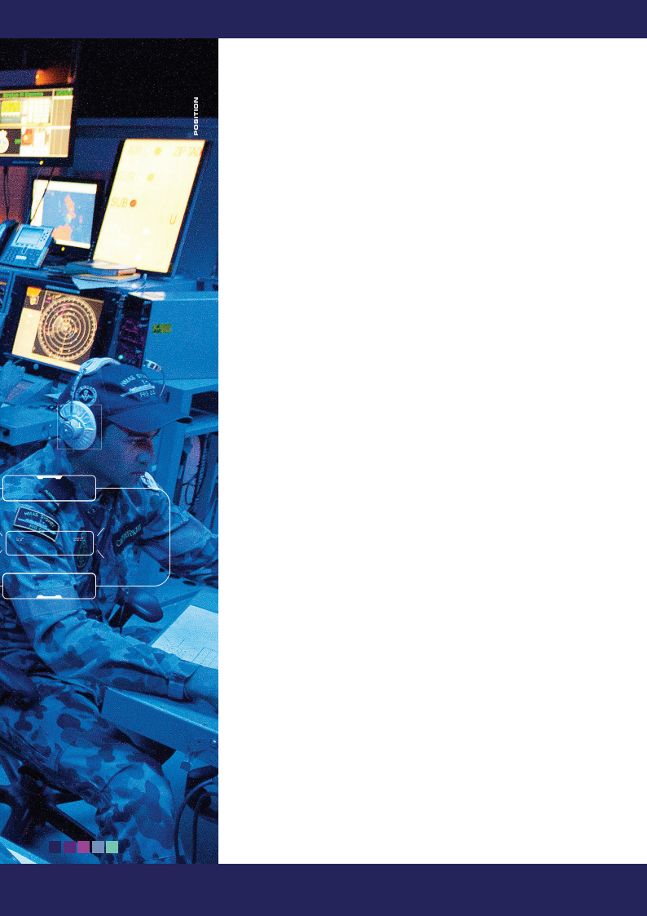**7**



STRATEGIC CONTEXT





WEATHER



TELECOMMUNICATIONS



NAVIGATION



MAPPING



SOCIAL MEDIA

ARMED FORCES

SOS

TRAFFIC

AGRICULTURE



TELEVISON

FINANCE



GAMING







AUSTRALIA IS CRITICALLY RELIANT ON SPACE

CAPABILITIES





Space systems are part of the national and global infrastructure upon which all nations depend. Access to space systems and space-derived information is crucial to Australia’s economic, social and national security interests. Lost or impeded access to space would impact Australian critical infrastructure such as the transport, financial and telecommunications sectors. It would also impact Government’s ability to deliver essential services such as emergency response, environmental monitoring, air and maritime surveillance, and traﬃc management.

Defence operates or utilises a range of space capabilities, including Positioning, Navigation and Timing (PNT), Satellite Communications (SATCOM), Intelligence Surveillance and Reconnaissance (ISR), and Space Domain Awareness (SDA).

Defence contributes to the allied and international partner shared capacity advantage of space capability through various partnered capabilities, memorandums and facilities with the United States and other Combined Space Operations initiative partners (Australia, Canada, France, Germany, New Zealand, United Kingdom and United States). These capabilities and arrangements highlight Defence’s valued contribution to allied space technological capacity, interoperability and exploits Australia’s geographical position.

Access to space capabilities is critical to Defence capabilities and activities, including intelligence collection, targeting, force projection and command and control.











**9**

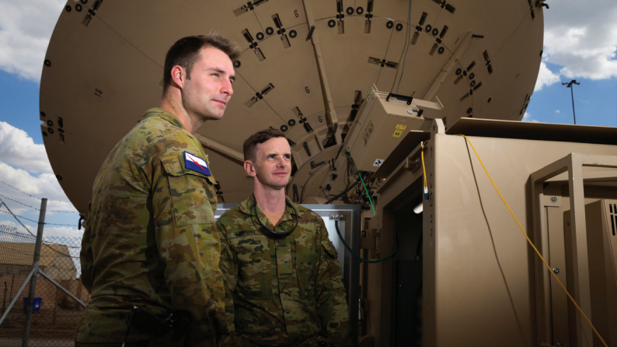

STRATEGIC CONTEXT







ACCESS TO SPACE CAPABILITIES IS CONTESTED

With the increase in development of counterspace capabilities occurring worldwide over the last decade, it is prudent to acknowledge that Defence faces threats to assured access to space capabilities, as do Defence’s allies and international partners. Defence’s reliance on access to space capabilities can be exploited by potential adversaries in a variety of ways.

Defence must improve Space Domain Awareness to DETER potential competitors through improved attribution of actions in space, including by leveraging access to partner information through the Combined Space Operations Initiative, and support the development of Whole of Government processes and capacity to mitigate and RESPOND to ‘grey zone’ activities.

Defence must develop and leverage new space capabilities to achieve and maintain information advantages over possible competitors. Australian sovereign systems may be vulnerable to cyber, electronic and kinetic attack, so Defence must improve the reconstitution, resilience and defence of the Defence Space Enterprise capabilities. Defence must also strengthen its counter intelligence capabilities to remain free from nefarious foreign activity.

‘Grey zone’ activities in space present a complex threat to Defence because such activities can exploit gaps in international legal frameworks and thereby delay or minimise response options. Australia takes an active role in international fora to SHAPE legal and regulatory frameworks for space activities and promote responsible behaviours in space and this position is supported by

Defence.

Defence’s international relationships with partners are critical to reducing the scale and impact of threats in space. However, even coalition military space capability is finite, must service many priorities and will itself be vulnerable to counterspace capabilities in times of conflict. Australia must develop sovereign space capabilities that contribute to its partnerships and assure Australian civil and military access to capabilities in space.

//

Defence must develop and leverage new space capabilities to achieve and maintain information advantages

**10**

|  |  |
| --- | --- |
| //  Defence needs to advocate  Australia’s continued  investment in diplomatic  efforts to regulate and  manage space |  |
| Effective space domain awareness is critical to managing the congestion in space, including distinguishing between deliberate adversary activity, the effects of space weather and accidental collision. Some of the required situational awareness is generated from sources outside Defence. For example, the United States supports a satellite catalogue to help inform orbital positioning. Before a satellite can use the electromagnetic spectrum and orbital resources needed to fulfil its mission, it requires an associated ‘satellite filing’. The filing is obtained through the International Telecommunication Union. Defence needs to advocate Australia’s continued investment in diplomatic  efforts to regulate and manage space, including spectrum use, noting that overcrowding, particularly in geostationary orbit, is increasingly limiting access to the electromagnetic spectrum.  Australia must ensure Space Domain Awareness capabilities complement Combined Space Operation initiative partner capabilities in providing resilience for Defence’s most valued partners. This will assist in the detection, tracking, identification and cataloguing of objects orbiting Earth and assists in developing an improved shared understanding of space activities.  SPACE IS ALSO INCREASINGLY CONGESTED  Space, particularly in low Earth orbits, is increasingly congested as well as being contested. The congestion has accelerated over the last decade partially due to ‘NewSpace’ approaches, also known as Space 2.0, which describes a commercial space industry approach focused on reducing costs and rapid technology insertion.  Space is no longer solely the domain of the super powers. Non-traditional state actors, smaller nations and commercial companies are venturing into new business models such as mega-constellations of small satellites, space resource extraction, on-orbit servicing and space tourism. As more space objects are launched, the number of operational satellites and the amount of debris will grow, adding to orbital congestion and increasing the risk of a collision in space. There is no effective international framework to reduce or manage these risks. |  |
|  | **11** |

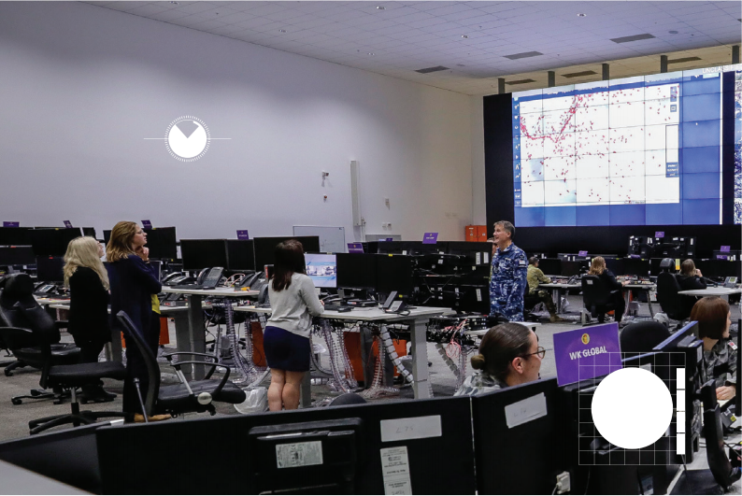

Image © NASA

STRATEGIC CONTEXT









DEFENCE HAS LIMITED SOVEREIGN SPACE CAPABILITIES

Defence has limited sovereign space capabilities and therefore leverages agreements with the United States, other international partners and commercial entities for many space capabilities. Defence has a number of collaborative arrangements with the United States for satellite communications and space domain awareness.

Defence conducts space operations through several areas, including the Australian Space Operations Centre at Headquarters Joint Operations Command and the Defence Network Operations Centre (satellite communications) at HMAS Harman. Defence is consolidating existing national, bilateral and multilateral space activities into a single operation – OPERATION DYURRA. OPERATION DYURRA is also the mechanism through which Australia contributes to OPERATION OLYMPIC DEFENDER, a United States led operation to provide space support to all contributing nations.

//

Defence has a number

of collaborative

arrangements with the

United States for satellite

communications and space

domain awareness.



**12**

|  |  |
| --- | --- |
|  |  |
| The importance of resilience, survivability and the ability to continue operating under gradual degradation of national and allied space capabilities cannot be understated. Defence must act at the speed of relevance to assure sovereign access to space capabilities.  Space is recognised as a Sovereign Industrial Capability Priority. Through the related Implementation and Industry Plans, the Government will outline the critical industrial capabilities that Australia requires a level of access to, or control over, to ensure our access to space and world-leading defence capability. These plans will also endeavour to address key gaps through Governmen actions and other support mechanisms.  GOVERNMENT INVESTMENT WILL ADDRESS KEY GAPS IN DEFENCE SPACE CAPABILITY  The Defence Strategic Update includes over AUD $17 billion investment in space capabilities to 2036.  These programs will deliver a mix of sovereign and collaborative systems to Defence including Positioning, Navigation and Timing, Satellite Communications, Intelligence Surveillance and Reconnaissance, and Space Domain Awareness.  Space Domain Awareness is fundamental to attribution in space. It provides a credible deterrence and encourages adherence to rules, norms and responsible behaviours in space. Defence will increase the scope and scale of space domain capabilities to improve situational awareness and attribution. | t |
|  | **13** |

VISION

Assured Australian civil and military access in space, integrated across Government, and in concert with allies, international partners and industry.

MISSION

|  |
| --- |
| Defence space capability and operations are integrated across Whole of Government. While Defence is capable of independent action, space capability is optimised when all facets of national power – including diplomatic, information, military and economic – are integrated and executed together.  Defence cannot achieve its vision in isolation from Australia’s partners. Australia will continue to work closely with its allies and international partners and build new relationships to further enhance its space capability and industry capacity, particularly with France, Germany and Japan.  While acknowledging Defence’s reliance on its partners, Defence must provide Government with sovereign space options. Government has provided over AUD $17 billion in funding through the Defence Strategic Update 2020 to enhance space capabilities and enable independent, sovereign action when required.  Industry is a critical partner in realising this vision. In creating the Australian Space Agency in 2018 and releasing the Australian Civil Space Strategy 2019-2028, the Government is aiming to triple the size of the Australian space sector and creating 20,000 domestic jobs by 2030. Defence will assist in advancing Australian sovereign space capability to support the development of a sustainable national space enterprise. |

DEFENCE SPACE STRATEGY

DEFENCE SPACE STRATEGY

|  |
| --- |
| Prepare Space Power to secure Australia’s interests in peace and war |
| Consistent with the other domains of Air, Maritime, Land and Cyber, Defence will Shape the space domain, Deter competitor actions and Respond as necessary to assure Defence’s access to space capabilities. |

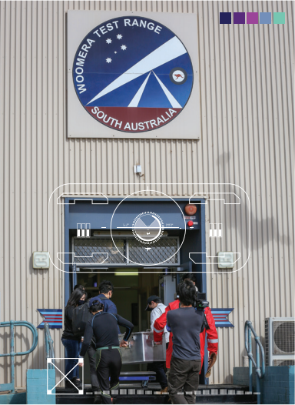

**14**

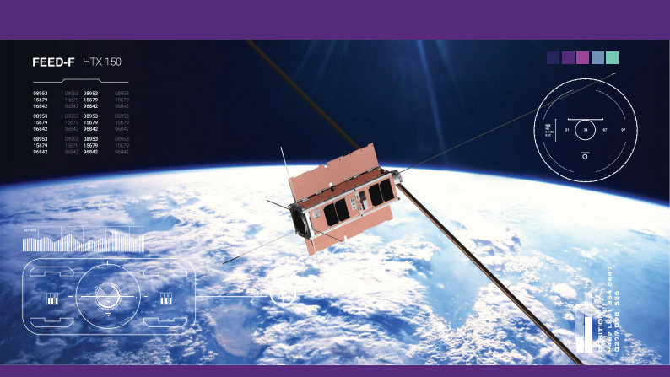

FIVE ‘LINES OF EFFORT’ WILL REALISE THE VISION









SOS







**1.** Enhance Defence’s space capability to assure

Joint Force access in a congested, contested and

competitive space environment.

**2.** Deliver military effects integrated across Whole of Government and with allies and partners in support of Australia’s national security.

**3.** Increase the national understanding of the

criticality of space.

**4.** Advance Australian sovereign space capability to support the development of a sustainable national space enterprise.

**5.** Evolve the Defence Space Enterprise to ensure a

coherent, efficient and effective use of the space

domain.

**15**

LINES OF EFFORT

LINES

OF EFFORT











|  |
| --- |
|  |









**16**



Credit: UNSW Canberra Space





**LOE1:** Enhance Defence’s Space capability to assure Joint Force access in a congested, contested and competitive Space environment.

|  |
| --- |
|  |

**Objective** **1a:**

Develop an operating concept and architecture for the Defence space enterprise that is aligned with Defence’s allies and international partners, but emphasises sovereignty and key Australian contributions.

Assurance of access to space capabilities in a congested, contested and competitive space environment cannot be achieved unless Defence develops a space architecture that is focused on capabilities that are resilient, can be reconstituted if compromised and defended if under attack. Defence will define operational space concepts and capability integration targets. Defence will develop an operating concept and architecture that is aligned with its allies and international partners that clearly articulates the value added by Australia and addresses the benefits and limits of sovereign, independent action in space. The architecture will also consider how space capabilities can be networked to maximise effect and enhance assured access to the space capabilities; improving the resilience of the Defence Space Enterprise.

Defence recognises the merit of considering alternate approaches to space capability development and acquisition. Some of these alternate approaches are inherent in a new commercial approach to space known as ‘NewSpace’. Attributes of interest to Defence include a small satellite focus that supports resilience from constellations, fast uptake of technology through regular constellation refreshes, ‘plug and play’ in the context of flexible and multi-purpose payloads, and potential to support sovereign space industry. Defence will explore a broad range of approaches to fill Defence space capability needs. Where appropriate, a balanced capability mix between large, exquisite satellites and small satellites across different orbital regimes will be considered. To sustain a mix of orbital regimes and satellite classes and respond quickly to reconstitute battle damaged assets, Defence anticipates it will need access to a responsive and assured space launch capability in the future. Defence will collaborate with the Australian Space Agency and other Government agencies to ensure space capabilities meet Australia’s national security needs.

//

Defence recognises the merit of considering alternate approaches to space capability development and acquisition

**17**

|  |  |
| --- | --- |
| LINES OF EFFORT |  |
| **Objective** **1b:**  Develop a space program roadmap that identifies quick wins and balances Australia’s space capability need and value for money with the need to develop and foster a nascent Australian space industry capability.  //  Defence will develop a space program roadmap that appropriately prioritises, sequences and resources the various projects and initiatives required to achieve the Space Domain vision | This strategy provides the over-arching goals and objectives for the Defence Space Domain – the ‘why’ and ‘what’ – but lacks the additional detailed ‘what’, and the ‘how’ and ‘when’ required for execution. Defence will develop a space program roadmap that appropriately prioritises, sequences and resources the various projects and initiatives required to achieve the Space Domain vision. The roadmap will identify opportunities to accelerate the transformation, balance capability requirements and value for money, and will also address the need to develop a nascent Australian space industry capability.  Defence projects requiring space-based capability will actively consider alternate approaches where a more dispersed satellite class and orbital regime capability solution than traditionally used could be incorporated. |
| **18** |  |





**Objective** **1c:**

Field assured SATCOM, space-based ISR and PNT capabilities.



Defence requires a resilient, agile and flexible satellite

communications system that can meet joint, coalition

and national requirements.

//

Defence requires a resilient, agile and flexible satellite communications system that can meet joint, coalition and national requirements.



Further, the 2020 Force Structure Plan called for the Australian Geospatial-Intelligence Organisation (AGO) to provide an end-to-end geospatial intelligence capability including space-based elements. AGO is progressively delivering sovereign space-based ISR capabilities including ground infrastructure to allow AGO direct and timely access to imagery from commercially owned- and-operated satellites. AGO is also planning to deliver a sovereign imagery capability via satellite to enhance coverage of required areas.

Defence will deliver assured access to space-based PNT services, resilient in contested and denied environments. Defence is also investigating alternative timing and positional systems for Australian Defence Force units to enable operations in a contested or denied environment.





















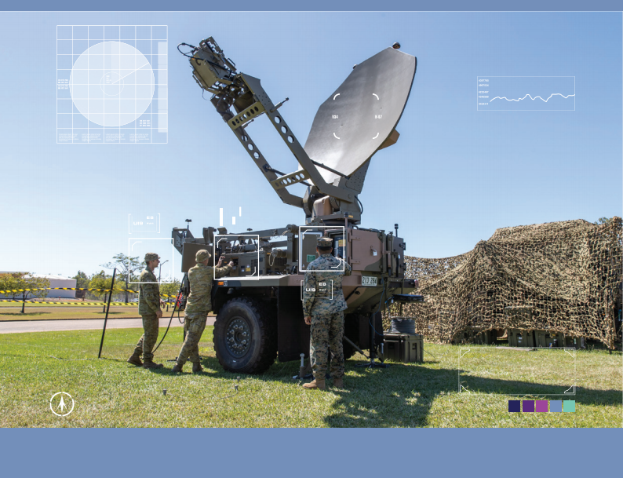**19**



Credit: ANU/Jamie Gilbert

LINES OF EFFORT

**Objective** **1d:**

Develop, enhance and field Space Domain Awareness and Space Control capabilities

Defence will assist Whole of Government efforts to assure Australia’s access to space capabilities. That assurance will include Whole of Government actions to support deterrence of actions contrary to Australia’s national interests in space. As identified in the 2020 Defence Strategic Update and 2020 Force Structure Plan, Defence will improve Space Domain Awareness capabilities and explore options to enhance Space Control capabilities to counter emerging space threats to Australia’s space capabilities.

Defence’s Space Domain Awareness projects will provide Australia with a sovereign Space Domain Awareness capability to detect, track, identify and characterise objects in space. Defence’s Space Domain Awareness capability will be progressively improved through evolving space command and control systems and developing sovereign space surveillance sensors. Defence will examine opportunities for Space Domain Awareness to be enhanced via space-based capabilities.

Defence will continue to identify Space Control gaps and opportunities to develop a credible Space Control capability, and space capability developers will actively seek to improve resilience of the space capabilities. Defence will explore options consistent with its commitment to be a responsible actor in space, in close consultation with the Department of Foreign Affairs and

Trade.











**20**



**Objective** **1e:**

Improve space intelligence and command and control (C2) capabilities that enable national security.



**Objective** **1f:**

Develop a detailed understanding of the

critical infrastructure that impacts on

Defence’s use of space.

Defence will evolve its space command and control capabilities to ensure it focuses on space as an operational, rather than benign, environment. Defence will enhance its space intelligence processes to support longer-term space risk assessments for the space domain and to contribute to its partnerships more substantially.

Defence will identify the critical space services it relies on to conduct Defence missions. This should inform a broader whole of Government activity to identify nationally critical space infrastructure and to formulate and undertake appropriate risk mitigation activities.

//

Defence will enhance its space intelligence processes to support longer-term space risk assessments for the space domain and to contribute to its partnerships more substantially









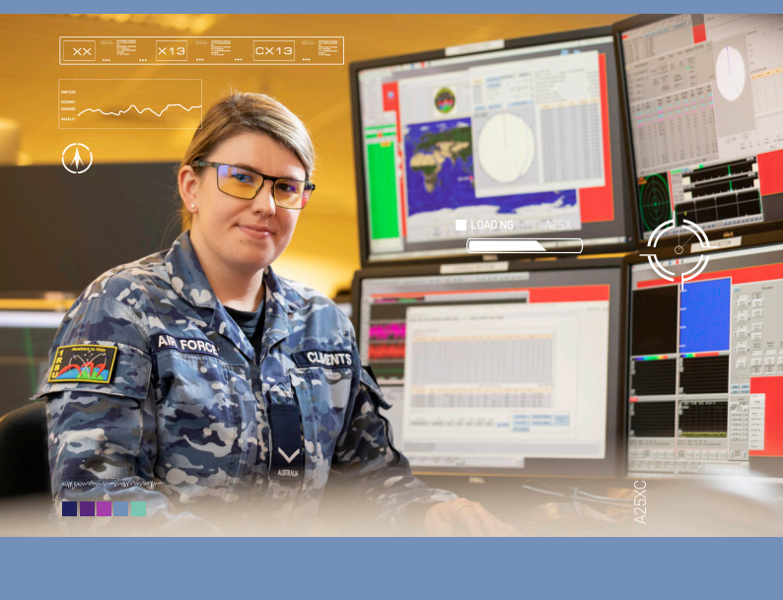**21**

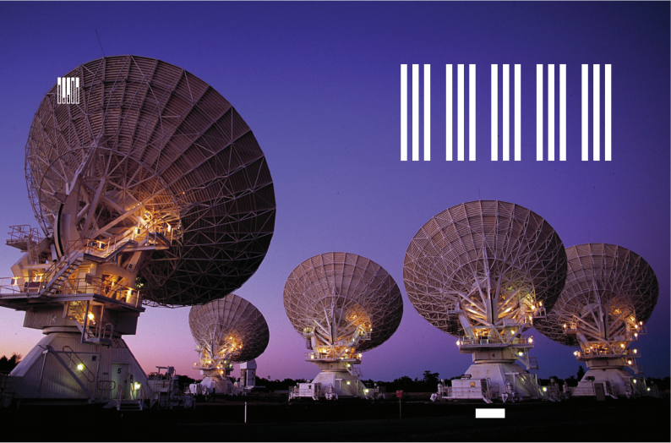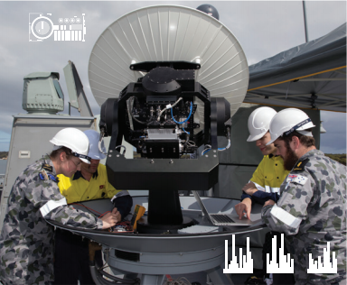

Credit: CSIRO

LINES OF EFFORT











**LOE2:** Deliver military effects integrated across Whole of Government and

with allies and partners in support of Australia’s national security.

**Objective** **2a:**

Build the national community’s understanding and collective eﬀorts to advance assured access to space capabilities.

Defence will provide military space expertise and lead thinking to help support Whole of Government efforts to develop a national security approach to space.



**22**



|  |
| --- |
| Satellites |

|  |
| --- |
| Maritime Joint Task Force |

|  |
| --- |
| Ground stations |



|  |
| --- |
| Amphibious Joint Task Force |

|  |
| --- |
| Networtk ops |

**Objective** **2b:**

Assist in developing inter-Departmental governance arrangements that can be used to apportion and prioritise national space capability eﬀort and tasking.

Defence, the Department of Foreign Affairs and Trade and the Australian Space Agency will oversee and coordinate whole of government efforts to meet the objectives of the Space Security International Engagement Framework. This will be primarily managed utilising the existing quarterly Space Coordination Committee meetings, chaired by the Australian Space Agency and the quarterly National Security Space Interdepartmental Committee meetings. The latter consider relevant priorities, trade-offs and resourcing challenges and elevate significant issues to the Space Coordination Committee and Government as required.

**Objective** **2c:**

Establish Space Control and deterrence

CONOPS/policy guidance.

Defence will evolve its doctrine, command and control procedures, and tactics, techniques and procedures to address Space Control as an integrated component of joint warfighting. Defence will also contribute to a Whole of Government deterrence approach – including diplomatic, information, military and economic – that will assist in assuring access to space-based capabilities.



**23**

|  |  |
| --- | --- |
| LINES OF EFFORT |  |
| **Objective** **2d:**  Cooperate with Combined Space Operations Initiative, allies and partners, and Whole of Government to maximise space capability options.  Defence’s multilateral space engagement occurs through the Combined Space Operations (CSpO) initiative. With Australia, the CSpO members include the United States, United Kingdom, New Zealand, Canada, France and Germany, with potential for this to expand. Defence will continue to leverage the CSpO forum to enhance its ability to operate together in space and deter actions against collective space assets. Defence will support more extensive engagement with the Department of Foreign Affairs and Trade, the Australian Space Agency and other Government agencies as Defence expands its role in space. | **Objective** **2e:**  Develop an eﬀective process for integrating  space capabilities with regional partners.  Australia will include space as part of regular engagement with regional countries. Coordinated by the Australian Space Agency, this engagement will be led by civil agencies, including the Bureau of Meteorology, Commonwealth Scientific and Industrial Research Organisation and Geoscience Australia. Defence will support this Whole of Government engagement with regional military partners, particularly providing advice on how Defence Space Domain capabilities can best be integrated across the spectrum of operations, from humanitarian assistance to conflict. |
| **24** |  |

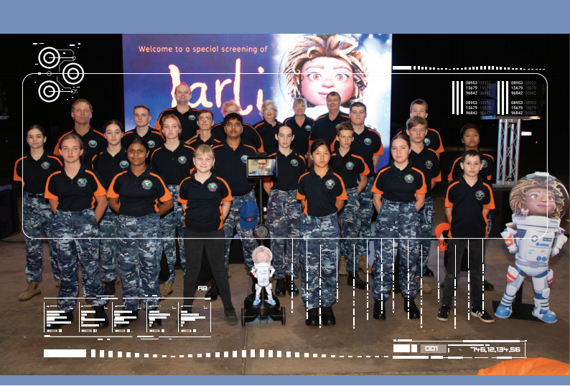



SOS





**LOE3:** Increase the national understanding of the criticality of space.

**Objective** **3a:**

Develop, periodically review and update

Defence’s central message on Australia’s

critical reliance on space capabilities and

the contested nature of the domain.

Defence will establish, evolve and consistently

communicate a set of clear messages to promote

Australians’ understanding of the importance of space,

the nature of the challenges it faces from space, and

the role of Defence in space.

**25**

|  |  |
| --- | --- |
| LINES OF EFFORT |  |
| **Objective** **3b:**  Shape the strategic environment to promote the safe and responsible use of space, including coordinating messaging across Whole of Government, and in concert with allies and partners.  Defence will support Whole of Government efforts to engage proactively with allies, international partners and multilateral organisations to protect Australia’s national interests and promote responsible behaviours in space. Defence will comply with Australia’s domestic and international legal obligations to ensure Australia is regarded as a responsible space actor.  Defence will work with other Government agencies to establish a clear understanding of each agencies roles and responsibilities, including where necessary, Defence Liaison Officers or embedded personnel, to facilitate a Whole of Government move to a coordinated national security approach to space. | //  Defence will work with other Government agencies to establish a clear understanding of each agencies roles and responsibilities...to facilitate a Whole of Government move to a coordinated national security approach to space |
| **26** | |  | | --- | |  | |





**LOE4:** Advance Australian sovereign space capability to support the development of a sustainable national space enterprise.

**Objective** **4a:**

Create and publish a coherent set of Defence priorities for Australian space industry development, in conjunction with the Australian Space Agency, other Government Departments and agencies that are fostering space industry development.

Defence will support the growth and sustainment of a national space enterprise as an integrated Whole of Government approach driven by the Australian Space Agency.

Prime Minister and Cabinet, the Department of Home Affairs, the Department of Foreign Affairs and Trade, Geoscience Australia, the Bureau of Meteorology, the Commonwealth Scientific and Industrial Research Organisation and academia all provide important contributions. Defence’s support to the Australian Space Agency includes participation in the Australian Space Agency Advisory Group, the Space Coordination Committee and embedding staff and providing liaison officers. Defence understands that Australian industry is more likely to invest when there is funding certainty. Defence will support this certainty by creating, publishing and updating a set of investment priorities for space, including estimated values and timelines. That plan will account for all areas of space industry relevant to Defence space activities.

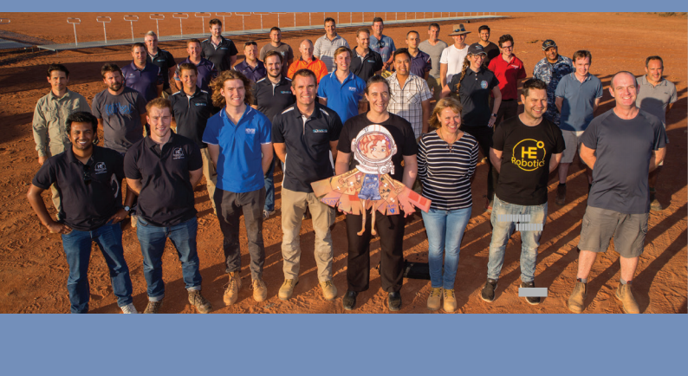













**27**



|  |  |
| --- | --- |
| LINES OF EFFORT |  |
| **Objective** **4b:**  Develop and publish an integrated Defence space science, technology and innovation strategy that is aligned to Defence’s critical space priorities to focus and shape the national space enterprise.  The Australian space sector is developing rapidly. Defence needs to shape and harness this emerging sector to achieve a cohesive and agile space science, technology and innovation system that can deliver Defence priorities. This focussed science and technology effort is outlined in the “More Together: Defence Science and Technology Strategy 2030” and further expanded in the Defence Capability Innovation Strategy. | In close consultation with space stakeholders, Defence will develop a space innovation strategy and plan to coordinate and shape the national space sector efforts to meet Defence’s critical needs. This will include Defence’s continuing investment in space innovation through the Next Generation Technology Fund, the STaR Shot Program, the Defence Innovation Hub and Integrated Investment Program risk mitigation activities. This will assist in defining Defence’s sensitive and critical space technologies to allow early identification and appropriate responses implemented consistent with the Defence Sensitive Technologies Policy. |
| **28** |  |



Credit: Silentium Defence

**Objective** **4c:**

Working as part of a coordinated Australian Space Agency and whole of Government eﬀort, identify areas of Australian industry competitive advantage and help to shape industry to meet Defence priorities.

//

Defence Industry Division

will identify the space capabilities of greatest national importance and help to shape Australian Industry focus

Working in conjunction with the Australian Space Agency and other relevant Government agencies, Defence Industry Division will identify the space capabilities of greatest national importance and help to shape Australian industry focus. Defence recognises the Australian space industry caters to a broad range of needs beyond Defence. Notwithstanding, Defence may benefit from repurposing civilian technology for military means, without having to invest in research and development or venture incubation. To identify such opportunities, Defence will actively coordinate and cooperate with other government agencies in innovation, research & development and acquisition activities.











































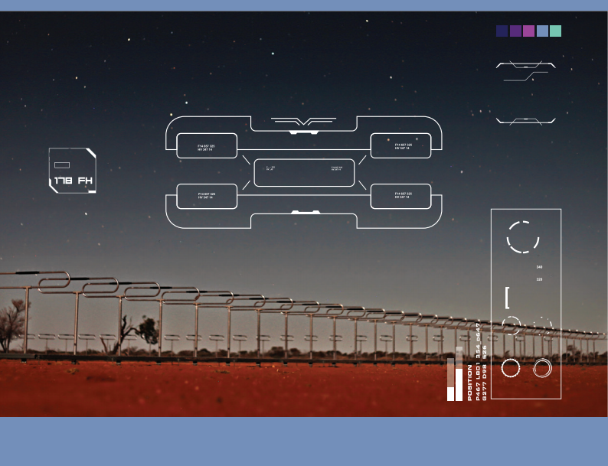**29**

|  |  |
| --- | --- |
| LINES OF EFFORT |  |
| **Objective** **4d:**  Develop an easily understandable regulatory framework that minimises regulatory hurdles  The regulatory framework needs to be evolved to clarify Defence specific authorities, relationships across Government and interdependencies with allied and partner regulatory frameworks. The regulatory scope includes, but is not limited to: launch and return, spectrum management and space worthiness. While spectrum management processes already exist within Defence, the regulatory and space worthiness framework will be progressively introduced. Defence wi retain its ability to regulate launch and returns. | **Objective** **4e:**  Establish clear points of contact between  . Defence and external stakeholders.  The scale of interaction between Defence, commercial entities and academia has increased significantly and requires coordination. Defence space capability has historically evolved under different capability managers and delivery organisations. This construct has often made it difficult for external stakeholders, particularly industry, to identify and engage with the appropriate Defence contact on space issues. Defence  ll will establish clear points of contact across the Defence  Space Enterprise that can be accessed by external stakeholders including other Government organisations, industry, allies, partners and academia. |
| **30** |  |



Credit: Inovor



**Objective** **4f:**

Increase the frequency, and deepen the scope,

of Defence engagement with Australian space

industry.

Defence recognises Australian industry as a fundamental input to capability. To ensure Australian industry is appropriately engaged throughout the space capability lifecycle, Defence will develop a comprehensive industry engagement plan in conjunction with the Australian Space Agency. This plan will seek to lift the tempo of industry engagement and ensure that priority agendas, investments and other strategic communications are clear and delivered through relevant channels. Defence will also support Australian space industry to foster engagement with small to medium enterprises.

//

To ensure Australian

Industry is appropriately

engaged throughout

the space capability

lifecycle, Defence will

develop a comprehensive

industry engagement plan

in conjunction with the

Australian Space Agency











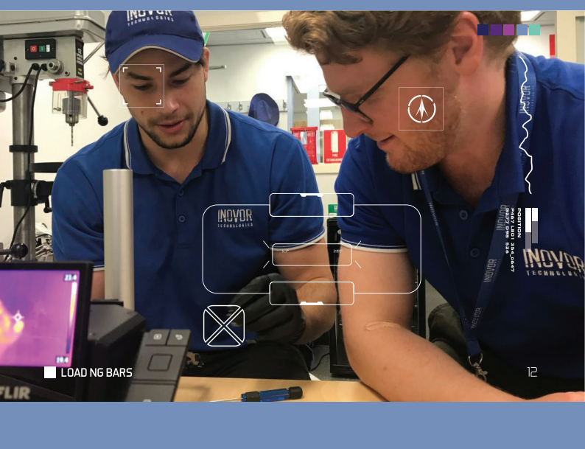**31**

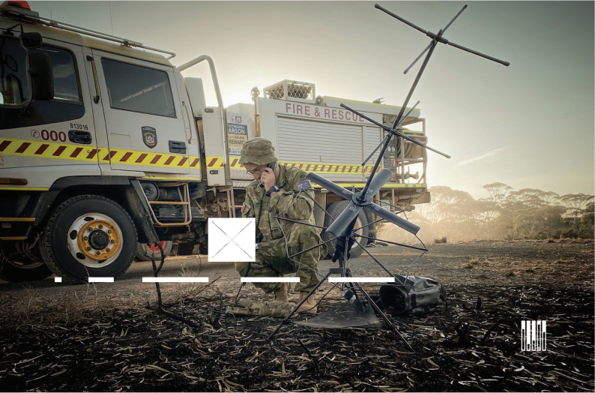

Credit: NASA

















LINES OF EFFORT















**LOE5:** Evolve the Defence Space Enterprise to ensure a coherent, efficient and effective use of the space domain.

**Objective** **5a:**

Develop the Defence Space Enterprise Concept, including the ability to inﬂuence from the strategic to tactical levels of command.

Defence will develop a Defence Space Enterprise Concept that addresses how space operations should be conducted within Defence’s multi-domain approach to operations. This will be accompanied by organisational level transformation to improve decision-making at all levels of command.

**32**

|  |  |  |
| --- | --- | --- |
|  |  |  |
| **Objective** **5b:**  Develop, execute and evolve the Strategic Workforce Plan for the Defence space capability, particularly to create viable and motivational career pathways.  Significant workforce growth and upskilling is required to realise the Defence space vision. A strategic workforce plan will seek to create space specific careers, standardise personnel management, identify training and education needs, and to identify and mitigate workforce risks. The strategic workforce plan will support the creation of viable and motivational career pathways, enabling Defence to attract and retain top talent and build long term skills in the sector, cognisant of the national workforce demands. | **Objective** **5c:**  Optimise and further invest in Defence’s Partner relationships, including resourcing Allied and international partner operations centres with Australian Defence staﬀ .  The posting of Defence personnel into allied and partner operations centres, such as the Combined Space Operations Center and other Five Eye partner organisations, will continue to be an important aspect of Defence’s partner relationship arrangements, along with interchange of specialists and ongoing international  liaison and collaboration. These relationships will continue and be further enhanced as Defence increases its sovereign space capability. |  |
|  |  | **33** |



Space Force

Credit: US

LINES OF EFFORT





























**Objective** **5d:**

**Objective** **5e:**

Evolve and expand space operations expertise and culture, leveraging posting and training opportunities with allies and partners.

To continually evolve Defence’s operational expertise and culture, Defence will continue to develop space power concepts and doctrine, and participate in overseas space exercises. Defence will include operational space concepts in ab initio training courses, regardless of Service, and in multi-domain warfighting training.

Evolve the doctrinal foundations of Defence

space power.

Defence will develop, implement and mature space power

doctrine. On a periodic basis, doctrine will be evaluated

with the Joint Doctrine Centre and Headquarters Joint

Operations Command to adjust and update.

**34**



Credit: US Space Force









|  |
| --- |
|  |



**35**

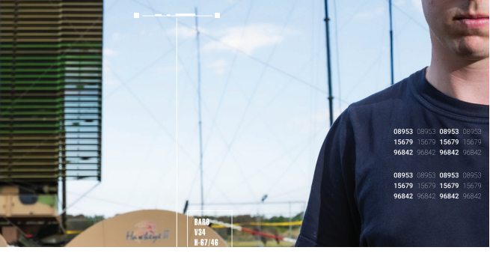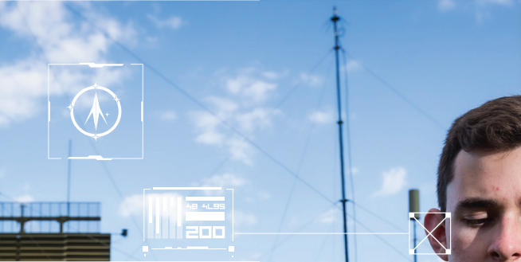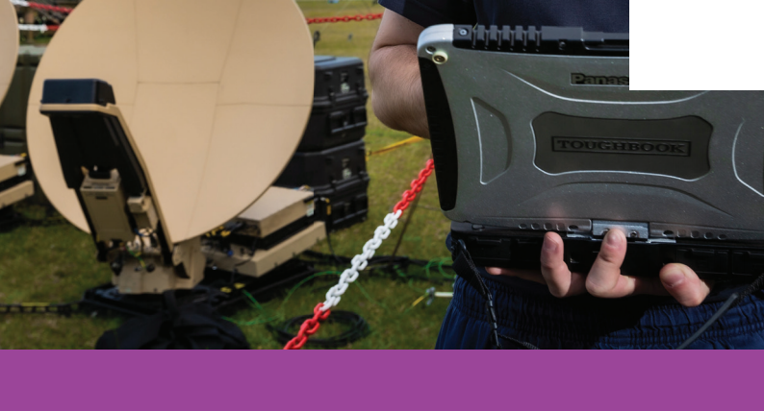













**36**

OUTCOMES



Credit: Curtin University

OUTCOMES

There are three conceptual delivery epochs for the Defence Space Strategy as depicted in the table below.

|  |
| --- |
|  |





|  |  |  |  |
| --- | --- | --- | --- |
| **Epoch** | **FOUNDATION** | **EVOLVE** | **MATURE** |
| **Focus** | • Organisation  • Concepts, roadmaps  architecture & plans  • Whole of Government integration  • Understanding of  space  • Industry engagement | • IIP delivery: SATCOM, SDA, Space Control, Space ISR  • Integrated Space  Control effects  • Industry Partnership  • Strengthened allied integration  • Architecture  transformation | • Mature workforce capability and capacity  • Space architecture  transformation  complete  • Additional space  capability  • Sustainable sovereign space enterprise |
| **Time-**  **frame** | 2021 - 2023 | 2024 - 2030 | 2031 - 2040 |

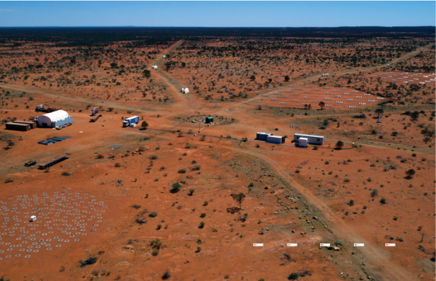

**37**

OUTCOMES

**Foundation** **(2021** **-** **2023)**

By 2023, Defence will have codified its Defence

Space Command and started to build the necessary workforce capacity and capability to exercise all space functions. Defence will have formulated the operational concepts, roadmaps, architectures and plans that

align and integrate all space related activities and operations across the Department. All Space Domain stakeholders will have a common understanding of their responsibilities and accountabilities. There will be a single point of contact for external agencies seeking space information, beyond established relationships. Defence will have significantly contributed to an integrated Whole of Government approach to space security and raised public awareness of the criticality of space. Defence’s engagement with Australian industry will be planned and focused, providing ample opportunity for Australian industry to prepare for commercial competition.

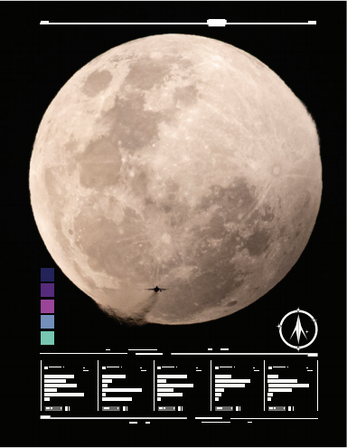

**Evolve** **(2024** **-** **2030)**

By 2030, Defence will have introduced into service most of the sovereign SATCOM, Space Domain Awareness, Space Control and Space-Based ISR capabilities programmed in the Integrated Investment Program. The new capabilities will be doctrinally and operationally integrated into Defence joint operations and national security approaches. Defence will have significantly strengthened its alliances and international partnerships through extensive sharing of space knowledge, people and capabilities. Defence will be a valued partner of the national space workforce, seconding personnel through industry, academia, research and development and whole of government agencies. New approaches to Defence capability will have been exploited to achieve an appropriate force mix that meets Space Mission Assurance requirements and provides Australian industry with the opportunity to compete for a sustainable pipeline of work. Defence’s relationship with Australian industry will continue to evolve, with greater opportunity for industry to contribute to all stages of the capability lifecycle, as a partner that not only satisfies Defence requirements, but also shapes them.

**Mature** **(2031** **–** **2040)**

By 2040, Defence will have a mature space workforce, with the necessary experience, skills and knowledge to meet the breadth of operational requirements. This outcome is the result of two decades of deliberate workforce management and continued investment in upskilling and career streaming. Defence space professionals are highly valued by its allies and international partners. Defence will continue to evolve the Defence Space Enterprise. Additional space capabilities will have been presented to Government to further assure Australian civil and military access to space capabilities.

**38**



ACTIVE & PASSIVE

OPTICAL SENSORS

SPACE LAUNCHES MISSILE LAUNCHES

SDA System Overview

**39**

**GEOSYNCHRONOUS**

**ORBIT**

35,786km

MEDIUM

EARTH

ORBIT

2,000km to

less than

GEOSYNCHRONOUS

ORBIT

LOW

EARTH

ORBIT

Up to

HUMAN SPACEFLIGHT

2,000km



KEY

 CURRENT SOVEREIGN

CAPABLITY

 NEW PROGAM

CAPABILITY

 US/ALLIANCE

CONTRIBUTION

SPACE BASED

SPACE WEATHER

“DEAD” SATELLITES

SENSOR - HEO



COMMUNICATIONS

OPIR SENSOR

LARGE DEBRIS

MANOEUVRES

SATELLITES





SMALL DEBRIS



GLOBAL NAVIGATION

EVENTS

SATELLITE SYSTEMS

NARROW FIELD

OF VIEW HIGH RESOLUTION

SPACE BASED SENSOR -

CUBE SATS

IMAGING SATELLITES

LEO





WIDE FIELD OF VIEW

LOW RESOLUTION

PASSIVE

ACTIVE &

PASSIVE RADAR

RF SENSOR





H

G

**E**

R

**C**

O

**N**

U

N

**E**

D

**F**

**E**

**D**

**N**

**A**

T

**M**

H

E

**M**

U

L

**O**

T

I

**C**

M

**D**

**PACE**

**S**

TE HI

G

A